Cover page Group 32

For the analysis, seven stocks from the S&P 500 index were selected: NVIDIA (NVDA), Microsoft (MSFT), Apple (AAPL), Amazon (AMZN), Johnson & Johnson (JNJ), Alphabet Class A (GOOGL), and Coca Cola (KO). Monthly stock prices for all securities within the selected period were obtained from Workspace. The price data is organized in the sheet “Main Data. A monthly risk-free rate of 0.050% was assumed. Monthly returns were calculated as the growth rate of closing prices, and the results show that the average arithmetic returns vary between 0.592% and 4.166%, while the standard deviations range from 4.389% to 13.054%, indicating differences in risk and return across the selected assets.
Task 1. First, the characteristics (expected return, standard deviation, and covariance) for the portfolio were computed through Excel formulas based on Sub-sample I & II. To compute the weights of the minimum variance portfolio, the Solver function in Excel was used. The cell for the portfolio variance (cell L28) was minimized while ensuring that the sum of all weights equaled 1 (cell L24). The optimal weights were:
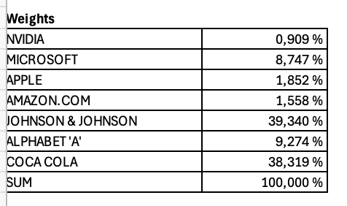
The resulting portfolio has an expected monthly return of E(Rp) = 0.896% and a standard deviation of σp = 3.615%, corresponding to a variance of 0.0013. This represents the lowest achievable risk among the seven securities. The portfolio’s risk is substantially lower than any individual asset, confirming the benefits of diversification.
Task 2. The efficient frontier was constructed in Excel using the Solver function. For a range of target standard deviations that increased by 0.5% for each iteration, the expected return was maximized subject to the constraint that the sum of all portfolio weights equals one and that the standard deviation of the portfolio was equal to the target standard deviation. Short selling was allowed. Nineteen target points were used instead of the suggested six, as the data showed a wide dispersion in standard deviations, and fewer points would have resulted in a rougher curve. For the inefficient frontier, the same constraints and target standard deviations were applied, but instead of maximizing returns, the objective was to minimize them. The graph below illustrates the efficient frontier for the seven selected stocks, showing for each level of standard deviation the portfolio with the maximum expected return.
Task 3
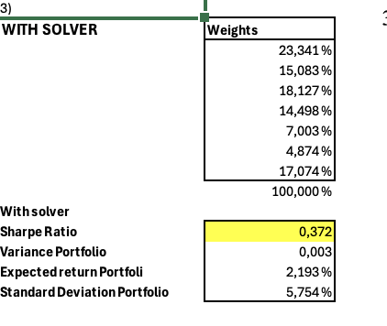
The tangency portfolio was obtained by maximizing the Sharpe ratio using both the Solver function and matrix calculations in Excel. In both methods, the excess returns and the inverse covariance matrix were used, with the constraint that the sum of all portfolio weights equals one
The optimal weights are presented above. The portfolio’s expected monthly return is 2.193%, the standard deviation is 5.754%, and the Sharpe ratio is 0.372. These results represent the risk-return combination that provides the highest reward per unit of risk.
The Capital Allocation Line (CAL) for the portfolio is given by: E(Rp) = 0.050% + 0.372σp
Task 4. To determine the optimal efficient portfolio for a risk aversion coefficient A = 4, the utility function U = E(rp) – ½ Aσp² was applied. In Excel, the optimal proportion invested in the tangency portfolio was computed using the formula w = (E(rM) − rf) / (AσM²), where E(rM) = 2.193%, rf = 0.050%, and σM = 5.754%.
This resulted in a weight of 161.799% for the market (risky) portfolio and -61.799% for the risk-free asset, indicating the use of leverage. The corresponding expected return is 3.5169% and the standard deviation is 9.3099%.
By multiplying the market portfolio weight (1.61799) by the individual asset weights from the tangency portfolio, the equivalent weights for all securities were obtained. A risk aversion coefficient of 4 implies leveraged investment in the risky portfolio, reflecting a moderate tolerance for risk.

